**UI Style Guide and Component Library**

[**https://www.figma.com/file/327iVSJunIVuYyc0cvjWgZ/9_UIUX_Dhania-Eka-Sofie?node-id=0%3A1**](https://www.figma.com/file/327iVSJunIVuYyc0cvjWgZ/9_UIUX_Dhania-Eka-Sofie?node-id=0%3A1)

**Color Style**

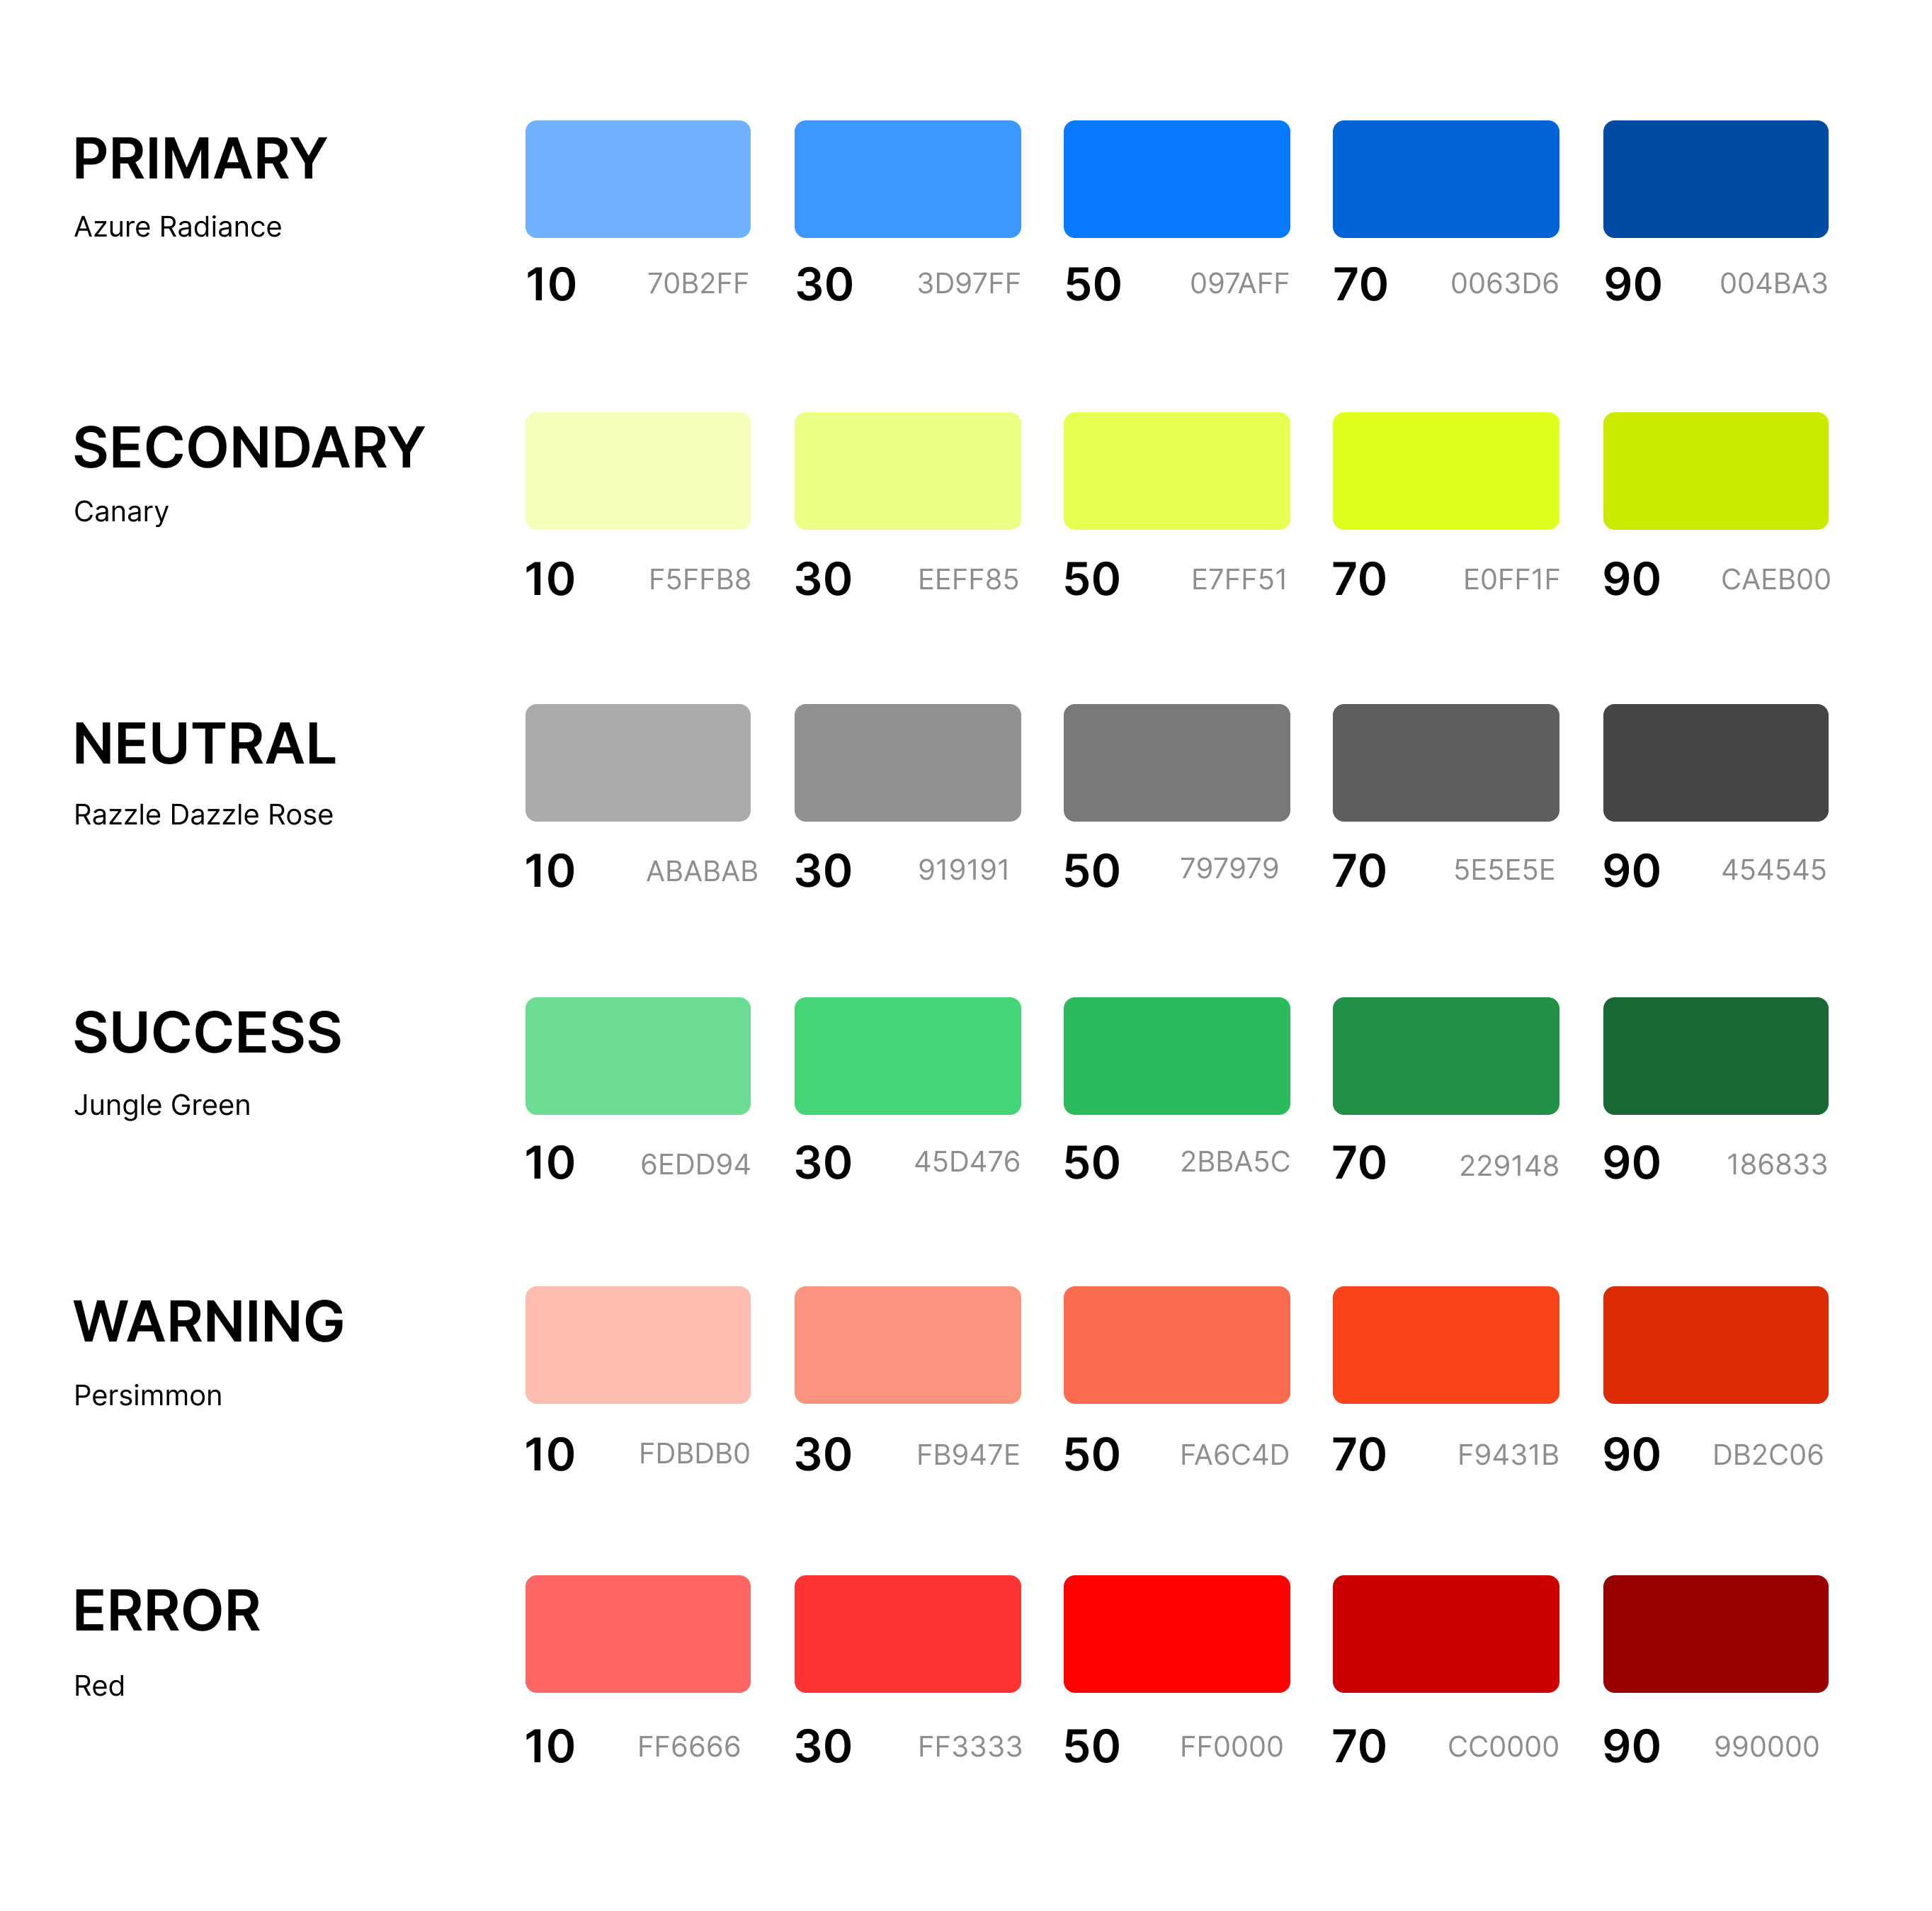

**Typography**

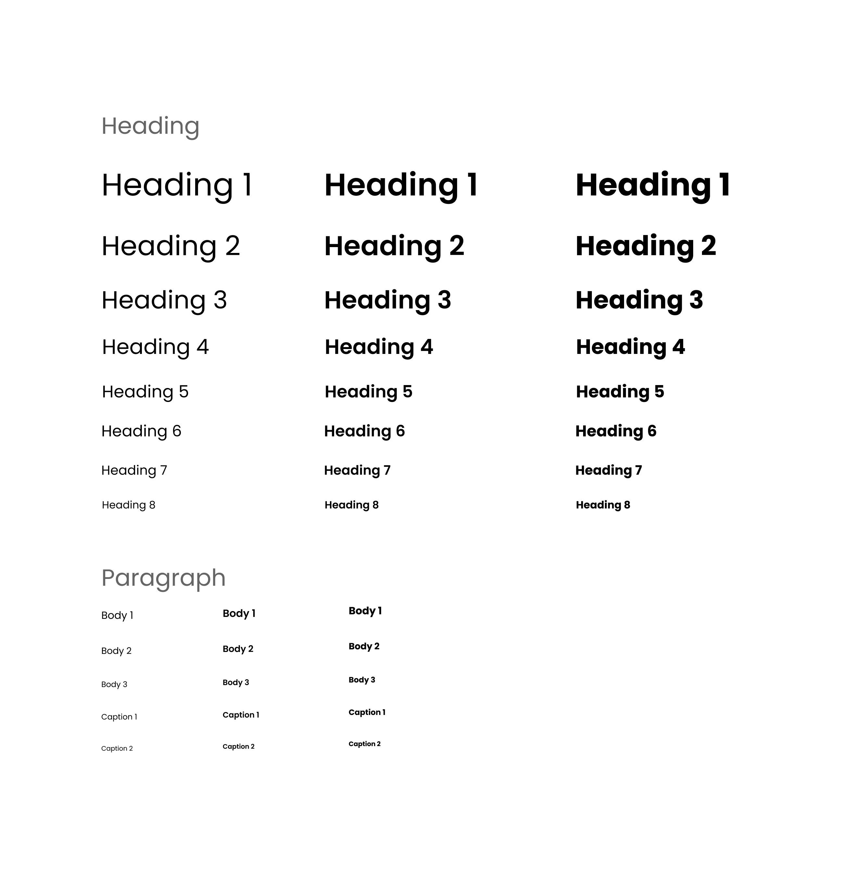

**Grid System**

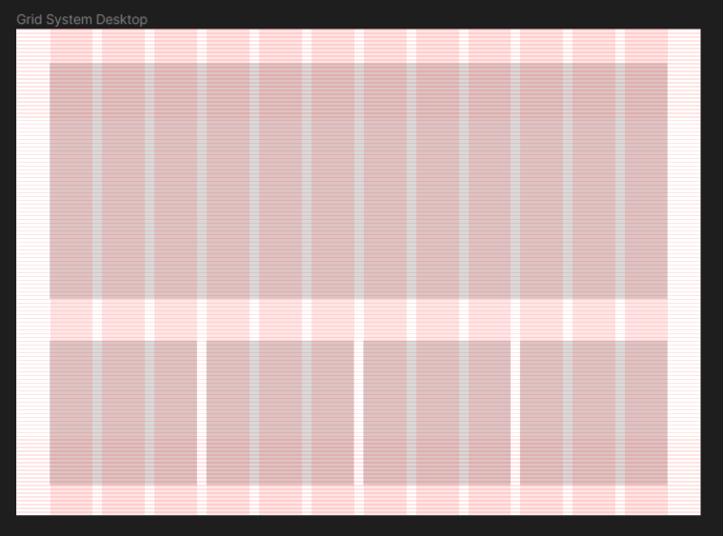

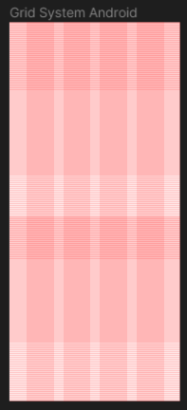

**Spacing**

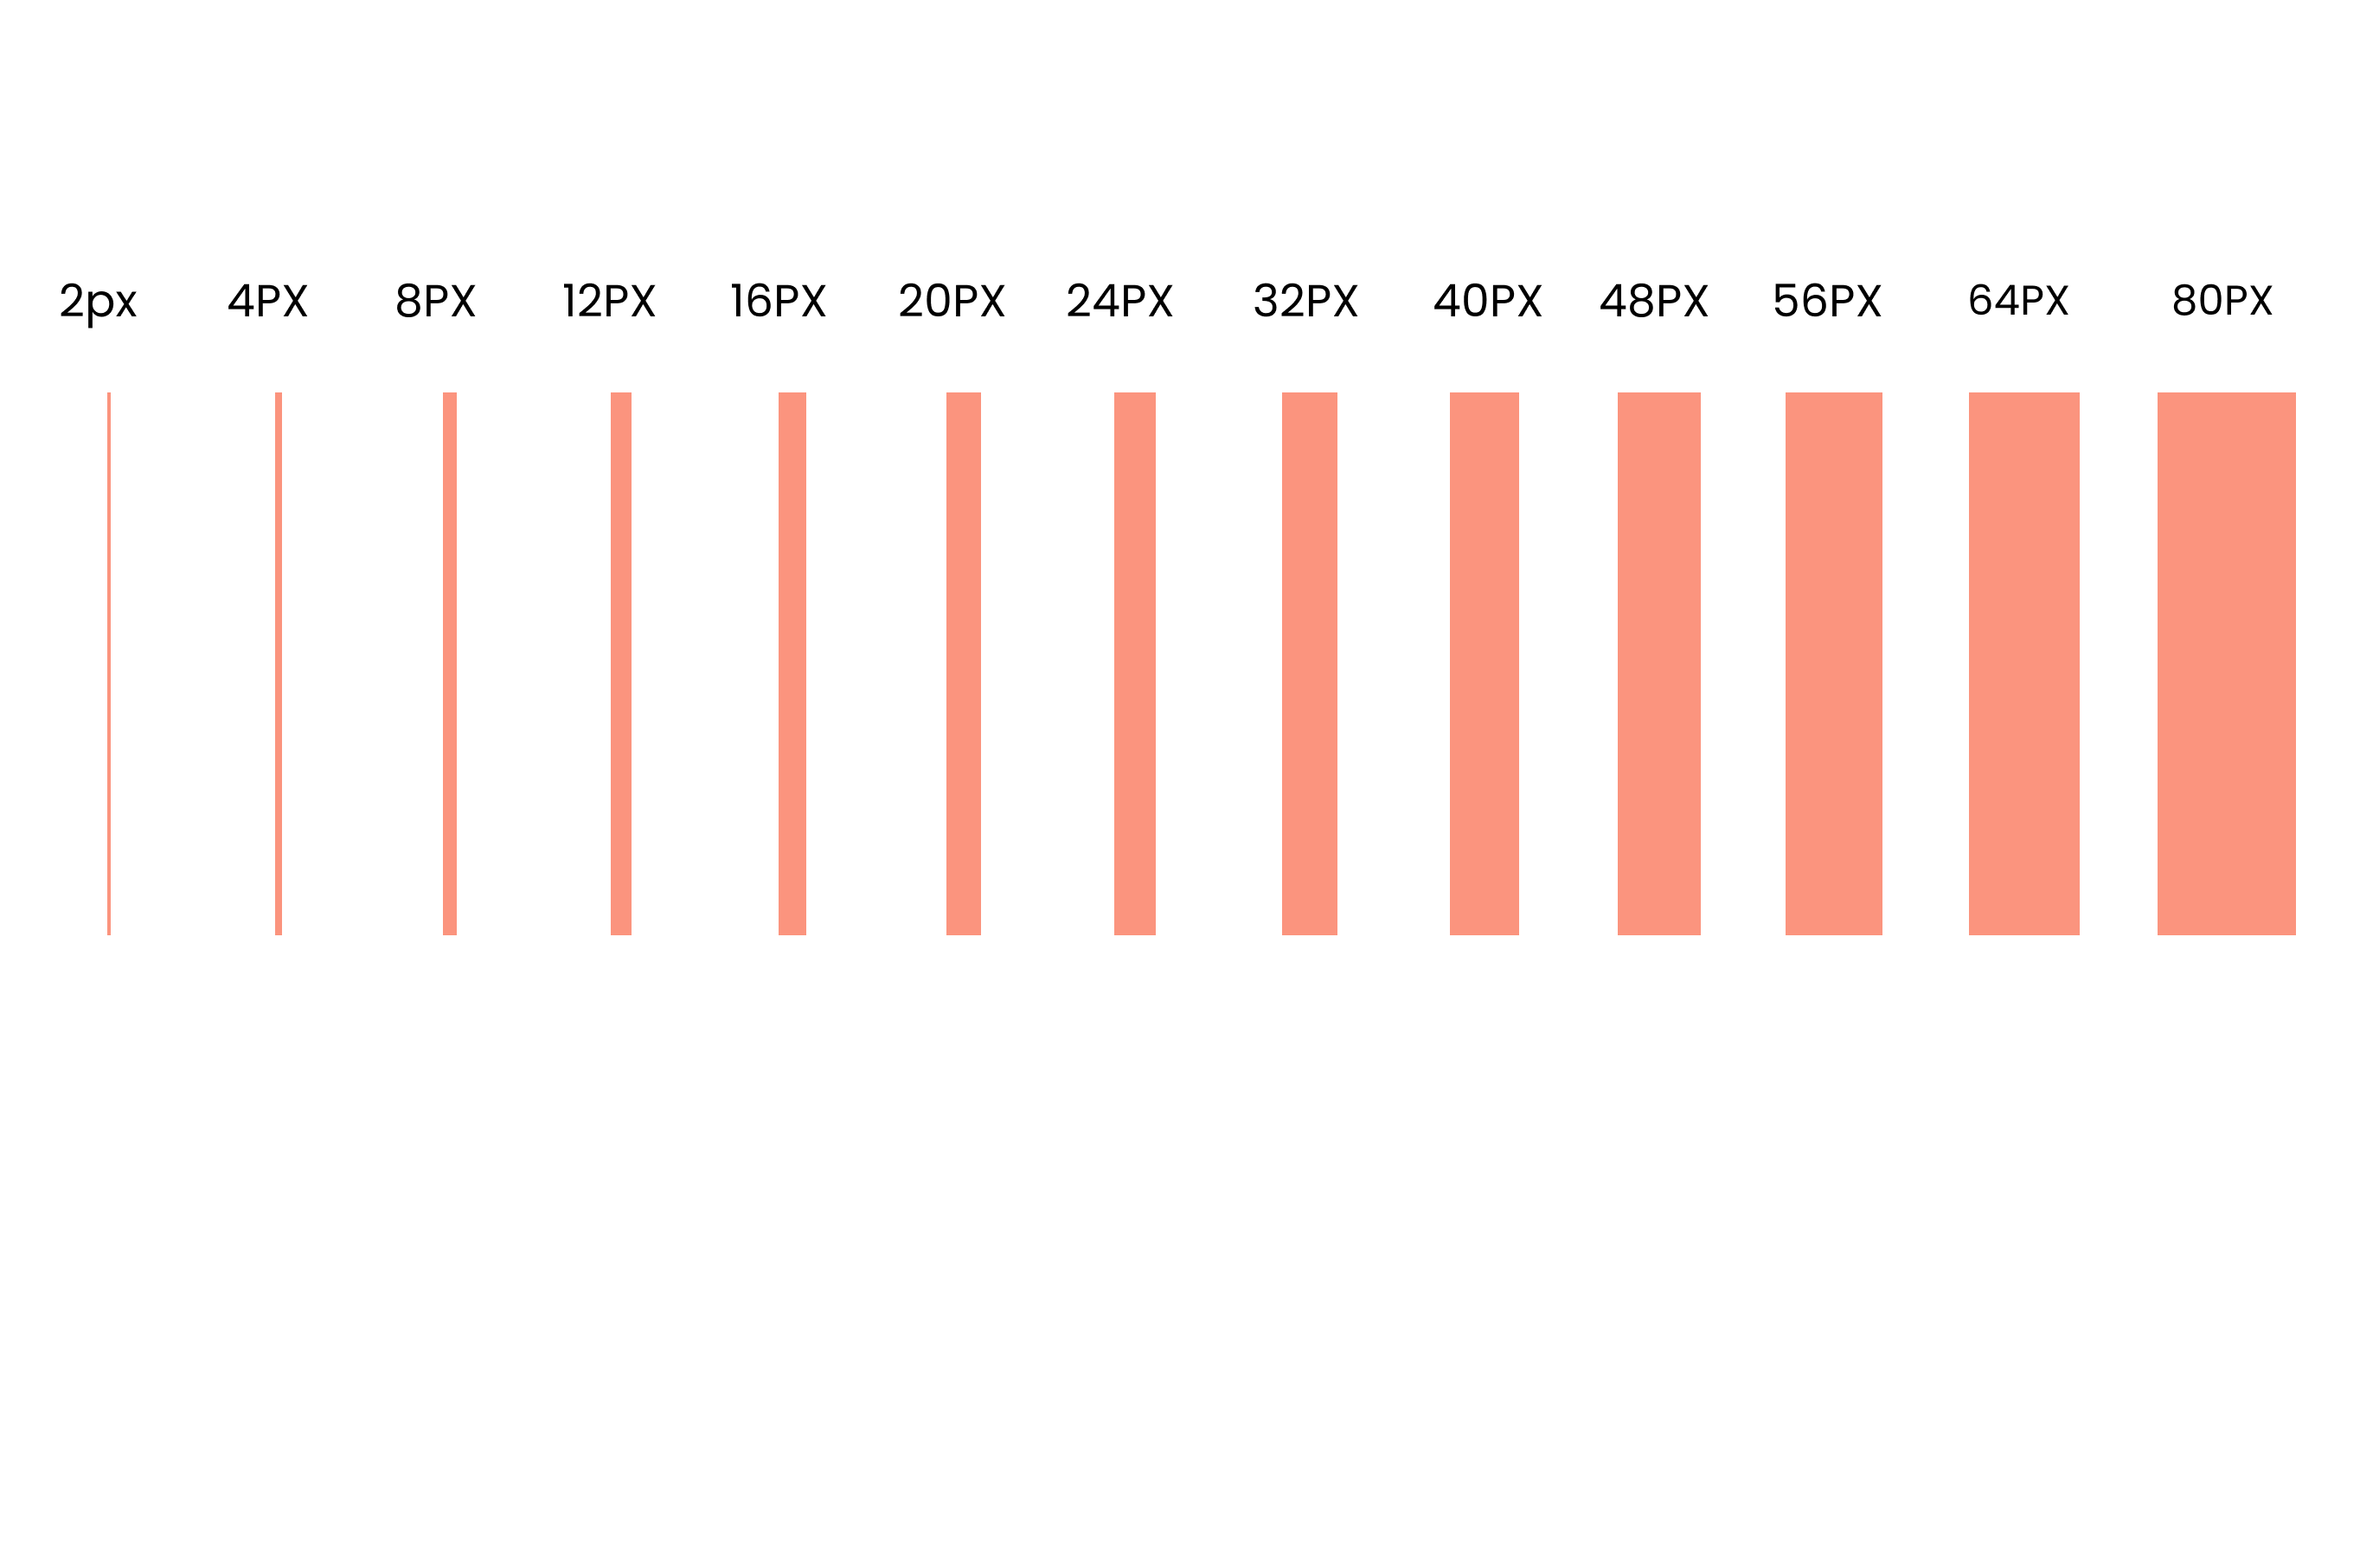

**Button**

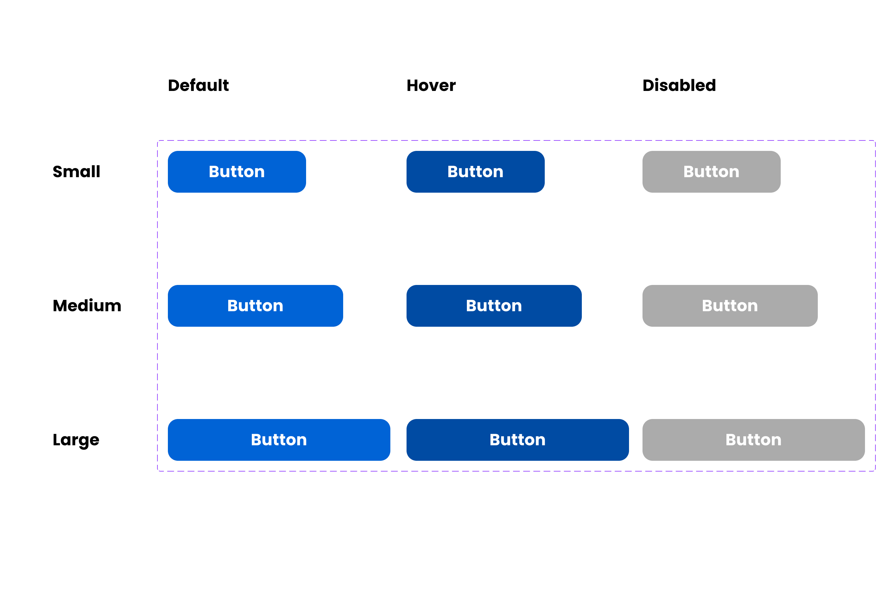

**Icons**

